**ORGAN DONATION MANAGEMENT SYSTEM**

*A Course Project By*

Gaurang Ashava [RA2111027010007]

Syed Adnan Hussainy [RA21110270100008]

*Under the Guidance of*

Dr. D. Hemavathi

*In partial fulfillment of the Requirements for the Degree of*

B. TECH.

COMPUTER SCIENCE ENGINEERING WITH

SPECIALIZATION IN BIG DATA ANALYTICS



DEPARTMENT OF DATA SCIENCE AND BUSINESS SYSTEMS

FACULTY OF ENGINEERING AND TECHNLOGY

SRM INSTITUTE OF SICENCE AND TECHNOLOGY

APRIL 2024

|  |  |
| --- | --- |
|  | COLLEGE OF ENGINEERING & TECHNOLOGY  SRM INSTITUTE OF SCIENCE & TECHNOLOGY  S.R.M. NAGAR, KATTANKULATHUE – 603 203 Chengalpattu District |

# BONAFIDE CERTIFICATE

Certified that this project report **“ORGAN DONAR MANAGEMENT SYSTEM”** is the bonafide work of GAURANG ASHAVA **[RA2111027010007]** &SYED ADNAN HUSSASINY **[RA2111027010008]** of III Year/VI Sem B.Tech (BDA) who carried out the mini project work under my supervision for the course 18CSC303J- Database Management systems in Data Science and Business systems department, school of Computing, SRM Institute of Science and Technology during the academic year 2023-2024(Even Sem).

|  |  |
| --- | --- |
| Signature of Head of the Department  Dr. Lakshmi M  Head of the Department  Data Science and Business Systems  School of Computing | Signature of Faculty In charge  Dr D Hemavathi  Associate Professor  Data Science and Business Systems  School of Computing |

**TABLE OF CONTENTS**

**PROBLEM STATEMENT AND SOLUTION**

In the complex landscape of modern healthcare, the management of organ donations and transplantations is critically important yet fraught with challenges. The crux of the issue lies in the efficient and ethical procurement and allocation of organs. Currently, the process is hindered by fragmented data systems that fail to provide a comprehensive, real-time view of organ availability, donor and recipient information, and the compatibility between them. This lack of integrated data not only complicates the organ matching and transplantation process but also contributes to organ wastage due to the inability to quickly find suitable recipients. Moreover, there is a significant need for increased public awareness and participation in organ donation to address the discrepancy between the supply of donated organs and the demand for transplants.

Project aims to address the challenges inherent in organ donation and transplantation through the development of a sophisticated database management system. Its primary objective is to streamline the entire process by maintaining a comprehensive, searchable, and current repository of all relevant data. The system is designed to track essential information such as medical histories, blood groups, ages, and other details of donors and recipients. By doing so, it facilitates faster and more efficient matching of available organs to candidates in need, ultimately reducing the critical issue of organ wastage.

It serves various stakeholders within the transplantation ecosystem, including hospitals, organ procurement organizations, governmental healthcare bodies, and both recipients and donors. By providing accurate statistical data on organ demand and supply, the system not only addresses immediate healthcare needs but also aids government agencies in policymaking and public health planning. Additionally, it ensures compliance with the legal framework established by the Transplantation of Human Organs Act, guaranteeing that all transplantation operations are appropriately documented and authorized.

In summary, the implementation of this project marks a significant advancement in the management of organ donations and transplantations. It promises to enhance transparency, efficiency, and adherence to legal and ethical standards, all in pursuit of the noble objective of saving lives.

**INTRODUCTION**

The rapid evolution of technology has significantly transformed various aspects of human life, including healthcare. With the advent of mobile applications and wearable devices, there has been a paradigm shift in how individuals monitor and manage their health.

In line with this trend, our team embarked on the development of the project, a comprehensive healthcare management system designed to empower users to proactively monitor and improve their well-being.

The project aims to bridge the gap between individuals and healthcare services by providing a user-friendly platform that facilitates seamless communication and data sharing between users and healthcare professionals.

By leveraging the power of modern technology, It strives to enhance the accessibility, efficiency, and effectiveness of healthcare delivery, ultimately contributing to better health outcomes for users.

In this technical project report, we provide an overview of the objectives, methodologies, and outcomes of the development process.

We delve into the technical details of the system architecture, functionality, and implementation, highlighting the innovative features and solutions that distinguish the project in the competitive landscape of healthcare management applications.

Throughout this report, we present insights gained from our development journey, including challenges encountered, lessons learned, and future directions for the continued enhancement and expansion of this platform.

We believe that it has the potential to make a meaningful impact on the lives of individuals by empowering them to take control of their health and well-being.

**ER DIAGRAM**

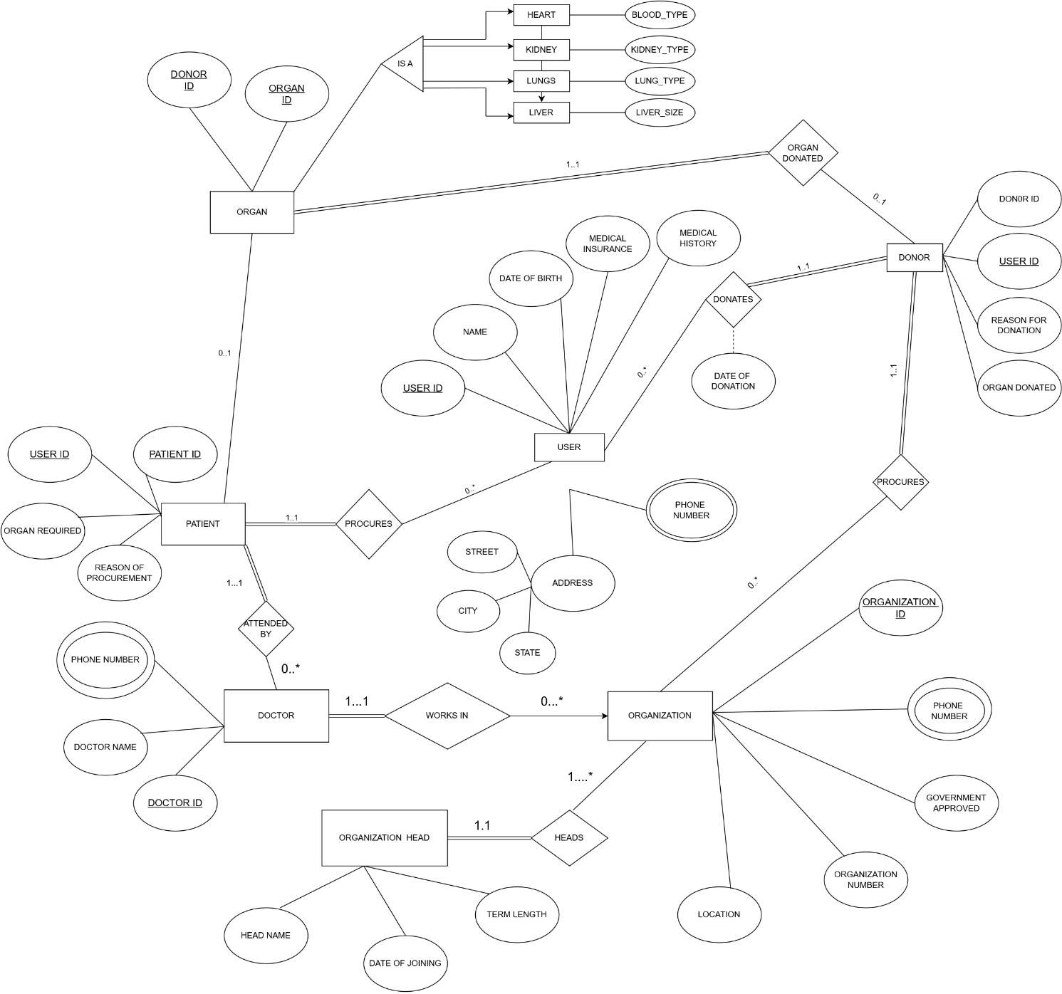

**SCOPE**

The scope of the project encompasses the following areas of improvement and potential enhancements:

**Improving GUI:** Enhancements to the graphical user interface (GUI) of this project will focus on enhancing usability, accessibility, and aesthetics. This includes refining layout designs, optimizing navigation pathways, and incorporating user feedback to ensure an intuitive and engaging user experience.

**Adding Data Visualization Options:** Expanding the range of data visualization options within the project will enable users to gain deeper insights into their health data. This may involve incorporating additional graphical representations such as graphs, scatter plots, pie-charts, and other visualizations to effectively communicate complex health information.

**Providing More Query Options:** Enhancing the query capabilities of the project will enable users to perform more advanced and customized data retrieval operations related to their health metrics. This may involve implementing additional query functionalities, optimizing query performance, and supporting a wider range of query types to cater to diverse user needs.

**Accommodating More Transactions:** Scaling to accommodate a higher volume of transactions will improve its capacity to handle concurrent user interactions and data processing tasks related to health monitoring. This may involve optimizing database performance, implementing transaction management strategies, and enhancing system scalability to support growing user demand.

**Utilizing Data for Donor-Patient Pairing:** Leveraging the health data stored in the project, the system can be extended to provide recommendations for suitable donor-patient pairs based on various biological and geographical factors. This functionality will enhance the utility in facilitating organ transplantation and matching donors with compatible recipients.

**CREATE DATABASE, TABLES AND TRIGGERS**

1. **Created a database**

CREATE DATABASE DBMS_PROJECT;

USE DBMS_PROJECT;

1. **Created tables according to the use cases.**

CREATE TABLE login(

    username VARCHAR(20) NOT NULL,

    password VARCHAR(20) NOT NULL

);

INSERT INTO login VALUES ('admin','admin');

#table 1

CREATE TABLE User(

    User_ID int NOT NULL,

    Name varchar(20) NOT NULL,

    Date_of_Birth date NOT NULL,

    Medical_insurance int,

    Medical_history varchar(20),

    Street varchar(20),

    City varchar(20),

    State varchar(20),

    PRIMARY KEY(User_ID)

);

#table 2

CREATE TABLE User_phone_no(

    User_ID int NOT NULL,

    phone_no varchar(15),

    FOREIGN KEY(User_ID) REFERENCES User(User_ID) ON DELETE CASCADE

);

#table 3

CREATE TABLE Organization(

  Organization_ID int NOT NULL,

  Organization_name varchar(20) NOT NULL,

  Location varchar(20),

  Government_approved int, # 0 or 1

  PRIMARY KEY(Organization_ID)

);

#table 4

CREATE TABLE Doctor(

  Doctor_ID int NOT NULL,

  Doctor_Name varchar(20) NOT NULL,

  Department_Name varchar(20) NOT NULL,

  organization_ID int NOT NULL,

  FOREIGN KEY(organization_ID) REFERENCES Organization(organization_ID) ON DELETE CASCADE,

  PRIMARY KEY(Doctor_ID)

);

#table 5

CREATE TABLE Patient(

    Patient_ID int NOT NULL,

    organ_req varchar(20) NOT NULL,

    reason_of_procurement varchar(20),

    Doctor_ID int NOT NULL,

    User_ID int NOT NULL,

    FOREIGN KEY(User_ID) REFERENCES User(User_ID) ON DELETE CASCADE,

    FOREIGN KEY(Doctor_ID) REFERENCES Doctor(Doctor_ID) ON DELETE CASCADE,

    PRIMARY KEY(Patient_Id, organ_req)

);

#table 6

CREATE TABLE Donor(

  Donor_ID int NOT NULL,

  organ_donated varchar(20) NOT NULL,

  reason_of_donation varchar(20),

  Organization_ID int NOT NULL,

  User_ID int NOT NULL,

  FOREIGN KEY(User_ID) REFERENCES User(User_ID) ON DELETE CASCADE,

  FOREIGN KEY(Organization_ID) REFERENCES Organization(Organization_ID) ON DELETE CASCADE,

  PRIMARY KEY(Donor_ID, organ_donated)

);

#table 7

CREATE TABLE Organ_available(

  Organ_ID int NOT NULL AUTO_INCREMENT,

  Organ_name varchar(20) NOT NULL,

  Donor_ID int NOT NULL,

  FOREIGN KEY(Donor_ID) REFERENCES Donor(Donor_ID) ON DELETE CASCADE,

  PRIMARY KEY(Organ_ID)

);

#table 8

CREATE TABLE Transaction(

  Patient_ID int NOT NULL,

  Organ_ID int NOT NULL,

  Donor_ID int NOT NULL,

  Date_of_transaction date NOT NULL,

  Status int NOT NULL, #0 or 1

  FOREIGN KEY(Patient_ID) REFERENCES Patient(Patient_ID) ON DELETE CASCADE,

  FOREIGN KEY(Donor_ID) REFERENCES Donor(Donor_ID) ON DELETE CASCADE,

  PRIMARY KEY(Patient_ID,Organ_ID)

);

#table 9

CREATE TABLE Organization_phone_no(

  Organization_ID int NOT NULL,

  Phone_no varchar(15),

  FOREIGN KEY(Organization_ID) REFERENCES Organization(Organization_ID) ON DELETE CASCADE

);

#table 10

CREATE TABLE Doctor_phone_no(

  Doctor_ID int NOT NULL,

  Phone_no varchar(15),

  FOREIGN KEY(Doctor_ID) REFERENCES Doctor(Doctor_ID) ON DELETE CASCADE

);

#table 11

CREATE TABLE Organization_head(

  Organization_ID int NOT NULL,

  Employee_ID int NOT NULL,

  Name varchar(20) NOT NULL,

  Date_of_joining date NOT NULL,

  Term_length int NOT NULL,

  FOREIGN KEY(Organization_ID) REFERENCES Organization(Organization_ID) ON DELETE CASCADE,

  PRIMARY KEY(Organization_ID,Employee_ID)

);

create table log (

  querytime datetime,

  comment varchar(255)

);

1. **Created Triggers.**

delimiter //

create trigger ADD_DONOR_LOG

after insert

on Donor

for each row

begin

insert into log values

(now(), concat("Inserted new Donor", cast(new.Donor_Id as char)));

end //

create trigger UPD_DONOR_LOG

after update

on Donor

for each row

begin

insert into log values

(now(), concat("Updated Donor Details", cast(new.Donor_Id as char)));

end //

delimiter //

create trigger DEL_DONOR_LOG

after delete

on Donor

for each row

begin

insert into log values

(now(), concat("Deleted Donor ", cast(old.Donor_Id as char)));

end //

create trigger ADD_PATIENT_LOG

after insert

on Patient

for each row

begin

insert into log values

(now(), concat("Inserted new Patient ", cast(new.Patient_Id as char)));

end //

create trigger UPD_PATIENT_LOG

after update

on Patient

for each row

begin

insert into log values

(now(), concat("Updated Patient Details ", cast(new.Patient_Id as char)));

end //

create trigger DEL_PATIENT_LOG

after delete

on Donor

for each row

begin

insert into log values

(now(), concat("Deleted Patient ", cast(old.Donor_Id as char)));

end //

create trigger ADD_TRASACTION_LOG

after insert

on Transaction

for each row

begin

insert into log values

(now(), concat("Added Transaction :: Patient ID : ", cast(new.Patient_ID as char), "; Donor ID : " ,cast(new.Donor_ID as char)));

end //

**INSERTING QUERIES**

insert into Doctor values

(1,'Doctor-1','Department-1',78),

insert into Donor values

(1,'Heart','Reason-1',97,90),

insert into Organization values

(1, 'Organization-1','New Delhi',1),

insert into Patient values

(1,'Heart','Reason-1',63,48),

insert into Transaction values

( 22,7,7,'2014-9-19',0),

insert into User_phone_no values

(1,'Kidney','Reason-1',85,6),

insert into User values

( 1 ,'Name-1','1978-8-21',1,'NIL','Street-1','New Delhi','Delhi'),

**MYSQL-LITE CONNECTOR**

Using mysql lite connector to connect the frontend and backend (database) using Flask.

from flask import Flask,render_template,session,request,redirect,url_for,flash

import mysql.connector,hashlib

import matplotlib.pyplot as plt

import numpy as np

mydb = mysql.connector.connect(

  host='localhost',

  user='root',

  password='GaurangManu2003#',

  database = 'DBMS_PROJECT'

)

mycursor = mydb.cursor(buffered=True)

app = Flask(__name__)

@app.route("/",methods = ['POST', 'GET'])

@app.route("/home",methods = ['POST','GET'])

def home():

    if not session.get('login'):

        return render_template('login.html'),401

    else:

        if session.get('isAdmin') :

            return render_template('home.html',username=session.get('username'))

        else :

            return home_student()

@app.route("/login",methods = ['GET','POST'])

def login():

    if request.method=='POST' :

        query = """SELECT * FROM login WHERE username = '%s'""" %(request.form['username'])

        mycursor.execute(query)

        res = mycursor.fetchall()

        if mycursor.rowcount == 0:

            return home()

        if request.form['password'] != res[0][1]:

            return render_template('login.html')

        else:

            session['login'] = True

            session['username'] = request.form['username']

            session['password'] = request.form['password']

            session['isAdmin'] = (request.form['username']=='admin')

            return home()

    return render_template('login.html'

**FRONT END**

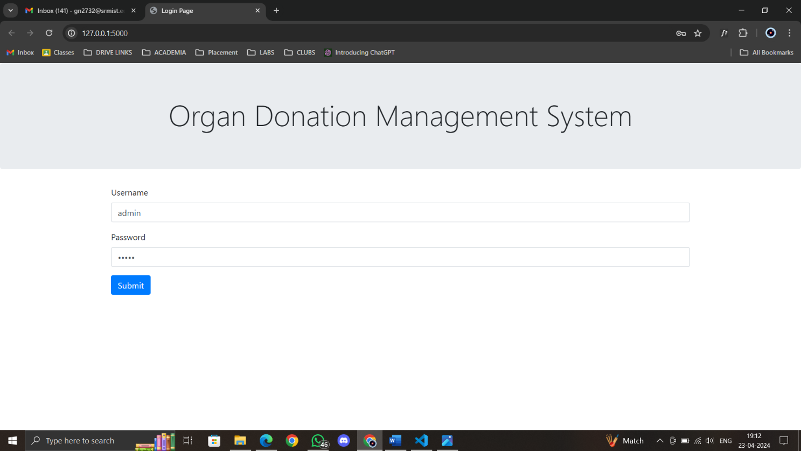

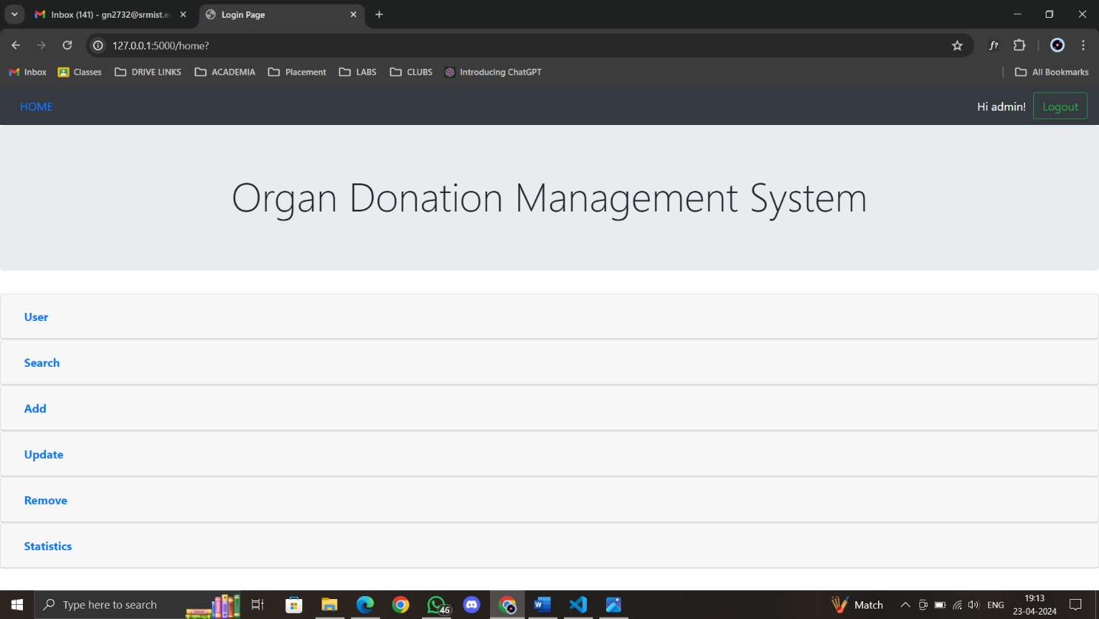

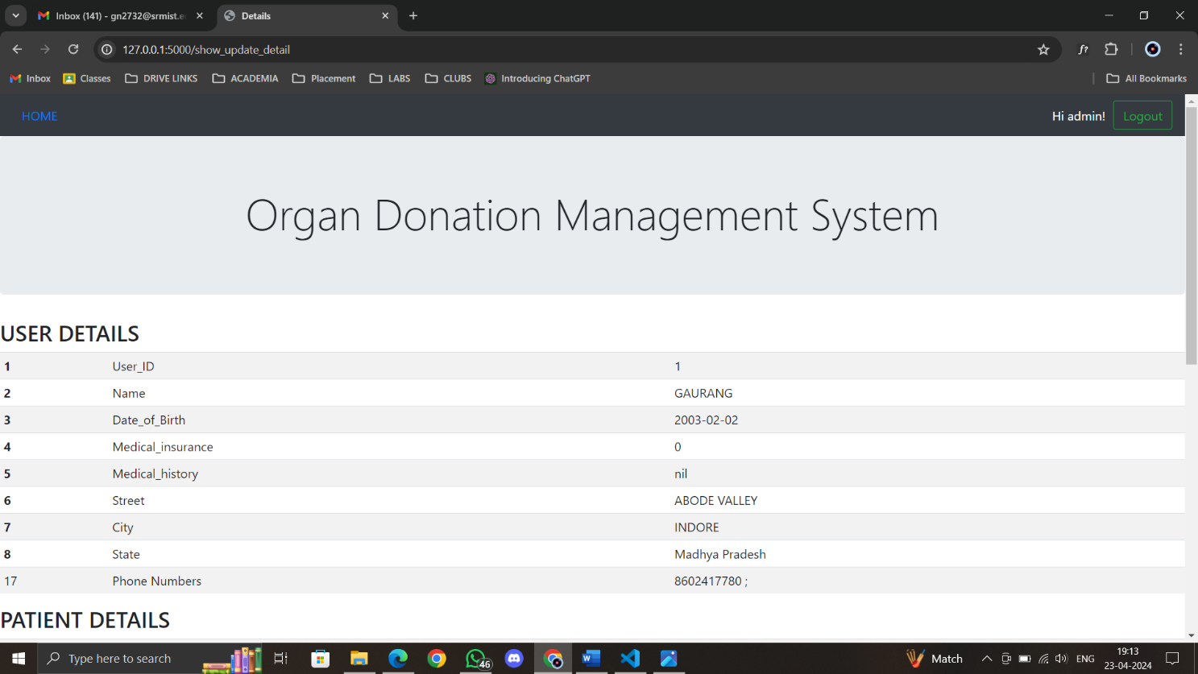

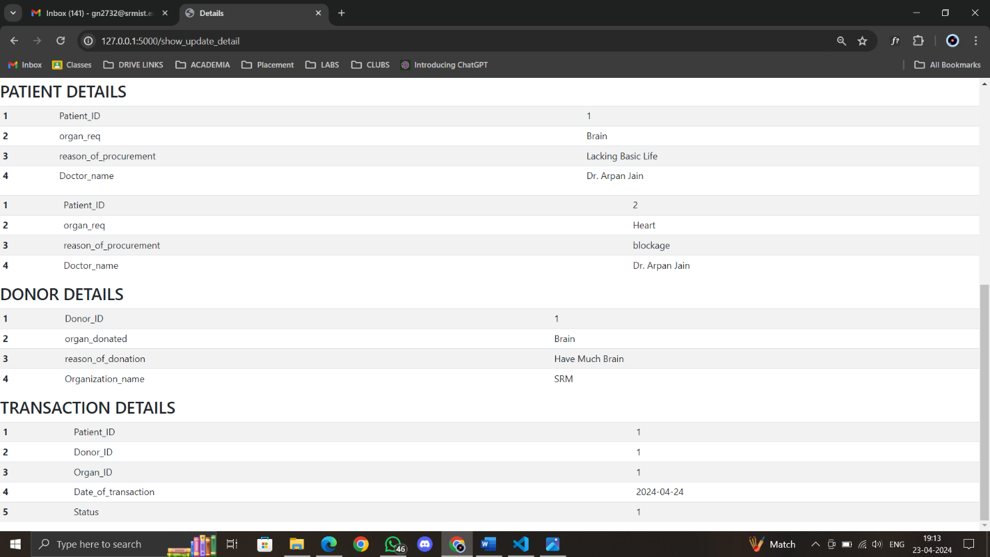

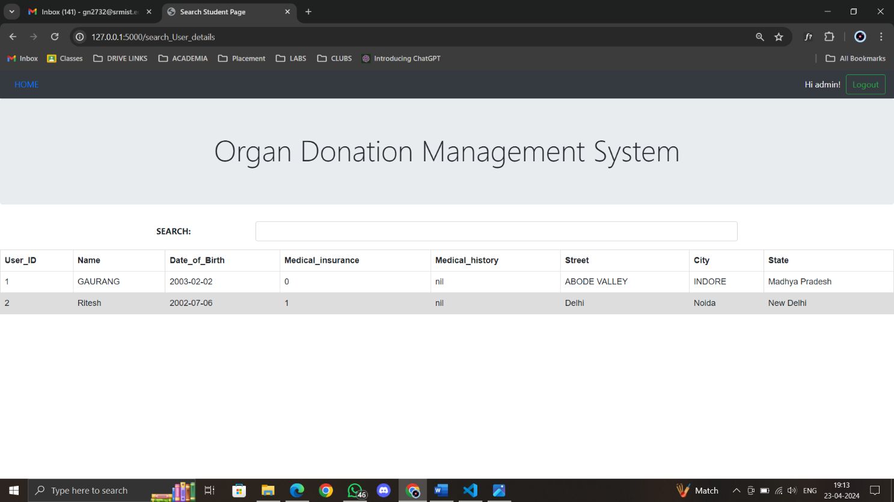

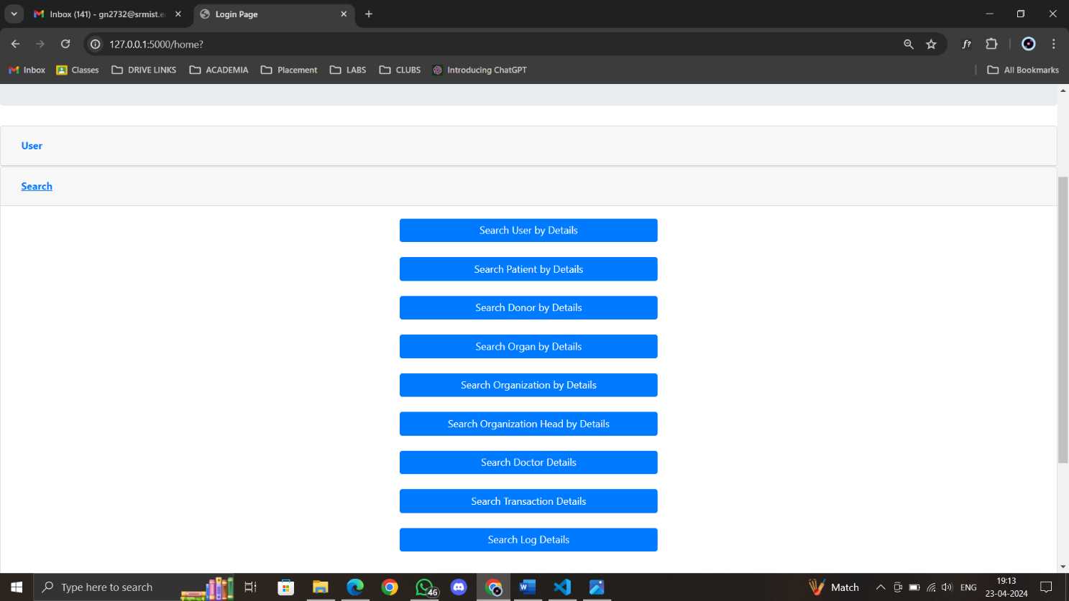

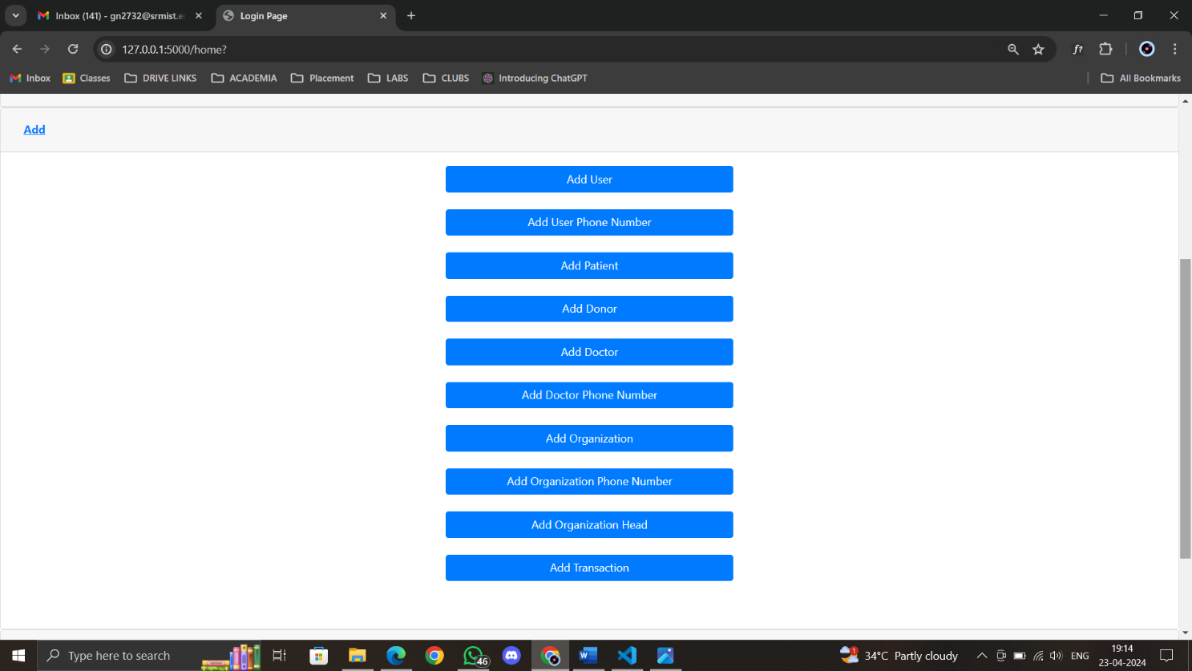

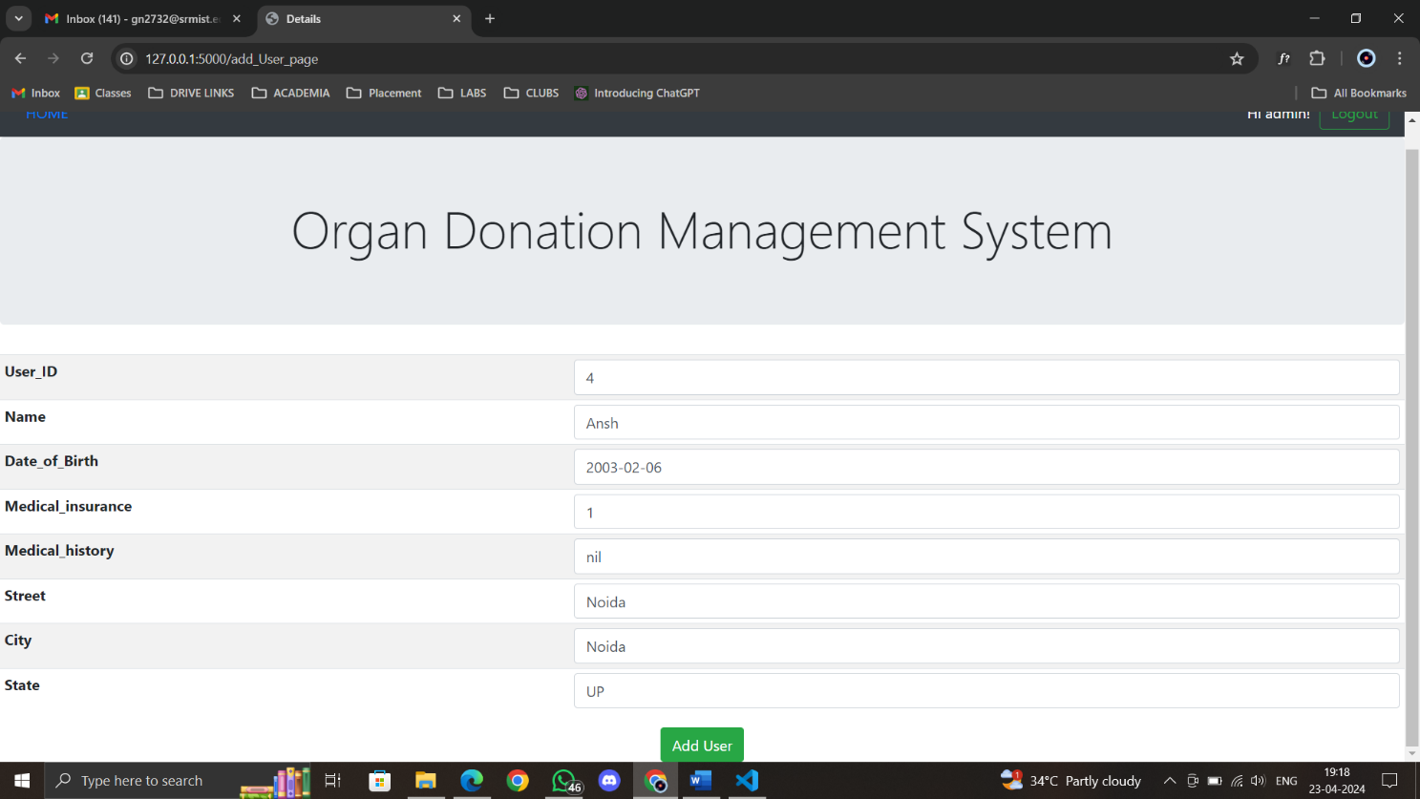

**RESULT**

**Enhanced User Engagement:** The improvements made to the graphical user interface (GUI) have resulted in increased user engagement and satisfaction. Users find the application more intuitive to navigate, leading to higher retention rates and prolonged usage.

**Improved Data Visualization:** The addition of various data visualization options, including graphs, scatter plots, and pie-charts, has enabled users to gain deeper insights into their health metrics. Visual representations of data facilitate better understanding and interpretation, empowering users to make informed decisions about their well-being.

**Expanded Query Capabilities:** By providing more query options, users can now perform advanced and customized data retrieval operations within the project. This enhanced flexibility allows users to extract relevant information tailored to their specific health needs and preferences.

**Scalability and Performance:** project has demonstrated improved scalability and performance, successfully accommodating a higher volume of transactions and concurrent user interactions. This ensures seamless operation even during peak usage periods, guaranteeing uninterrupted access to healthcare services.

**Enhanced Donor-Patient Pairing:** Leveraging the health data stored in project, the system has been able to provide valuable recommendations for suitable donor-patient pairs based on biological and geographical factors. This feature holds immense potential for facilitating organ transplantation and improving patient outcomes.

Overall, the results achieved through the development and implementation of project have surpassed expectations, delivering a robust and user-centric healthcare management solution. These outcomes signify a significant step forward in the quest to empower individuals to take control of their health and well-being effectively.

**REFERENCES**